Developing a shared Strategy for 2019-24 across
Lancashire and South Cumbria Integrated Care System
Introduction
This paper is intended to support the consideration of a proposed strategic narrative for the Lancashire and South Cumbria (L&SC) Integrated care System (ICS) by Clinical Commissioning Groups (CCG) Governing Bodies, Provider Trust Board and Local Authority leadership teams. The paper also outlines the process of engagement on that narrative that we are proposing to undertake.
The slide set attached proposes that the Lancashire and South Cumbria (L&SC) Integrated care System (ICS) endorses eight partnership priorities for changing the way we work as a system – priorities which enable us to explain our vision for future system working to our staff, patients, citizens and stakeholders and to set out how working in partnership will enable us to tackle our most significant challenges.
Current position
- Members will be aware of the wide-ranging expectations set out in the NHS Long Term Plan. These include the obligation on Integrated Care System leaders (which includes the leaders of Clinical Commissioning Groups, Providers and Local Authorities) to facilitate discussions with citizens, staff, stakeholders and partners about how we intend to respond to the Long Term Plan, address the challenges facing our system and support our communities to improve their own health and wellbeing. These conversations are intended to shape a Five Year Strategic Plan for the Integrated Care System to be published in the autumn of 2019.

- Over the last 12 weeks, around 250 leaders and senior representatives across the Lancashire and South Cumbria (L&SC) health and care system have been involved in discussions about the case for changing the way we work as a system and the development of a number of “strategic propositions” for working differently. During the course of March and April, each proposition has been refined into a priority statement by senior colleagues working in the system, taking note of the feedback received through workshops and other conversations with leaders. Whilst this recent work has stemmed from the NHS Long Term Plan, our approach in Lancashire and South Cumbria has been to create a process to develop a partnership strategy which complements the core strategies of other key partners including Local Authorities, educational institutions and local enterprise partnerships.

- This work has now been consolidated into set of slides, which was approved for wider engagement by the Integrated Care System Board at its April meeting. The slide pack is attached to this paper and is introduced below.

- In parallel with this strategic work, Clinical Commissioning Groups and Trust operational plans for 2019/20 have been developed in line with national NHS planning guidance published in December. This work has been co-ordinated across the Integrated Care System, with emphasis placed upon commissioners and providers working closely together in Integrated Care Partnerships (ICPs) to develop their plans. Once finalised and signed off by NHS England and NHS Improvement, the aggregated 2019/20 Operational Plan will be viewed as year 1 of the Integrated Care System five-year strategy. It has been important, therefore, to reflect the spirit of the proposed strategic priorities in the development of the 2019/20 operational plans.

- Members should note that NHS England & NHS Improvement have confirmed that further guidance about the development of Integrated Care System 5 year strategies is expected to be published in May as part of the Implementation Framework for the Long Term Plan. However, the Lancashire and South Cumbria (L&SC) Integrated care System (ICS) Board considered the early development of priorities for action was vital to ensure that meaningful engagement with staff and communities could be held over the summer in order to inform the final Integrated Care System five-year strategy.
Building the Strategic Narrative
- This process of developing the attached document has not followed the typical approach to developing strategy which might be adopted in a single organisation. The evolution of this work can be explained by introducing elements of the slide set as follows:

- The Integrated Care System strategic narrative needs to be built on a unifying vision which can represent the intent of all of the Integrated Care System partners (not just the NHS) in a straightforward and convincing way. The vision statement set out in the document is as follows:
Our vision for Lancashire and South Cumbria is that communities will be healthy and local people will have the best start in life, so they can live and age well.
At the heart of this are the following ambitions:
- We will have healthy communities
- We will have high quality and efficient services
- We will have a health and care service that works for everyone, including our staff

- The narrative must add value to the existing organisational and Integrated Care Partnership strategies already in place. Most of our organisations and Integrated Care Partnerships are framing their local strategies around their work to improve population health, integrate care in neighbourhoods, manage their resources better and build effective local partnerships. The following illustration is included in the slide set [slide 8] to introduce the added value of the actions we determine are best taken across the wider Lancashire and South Cumbria (L&SC) partnership:
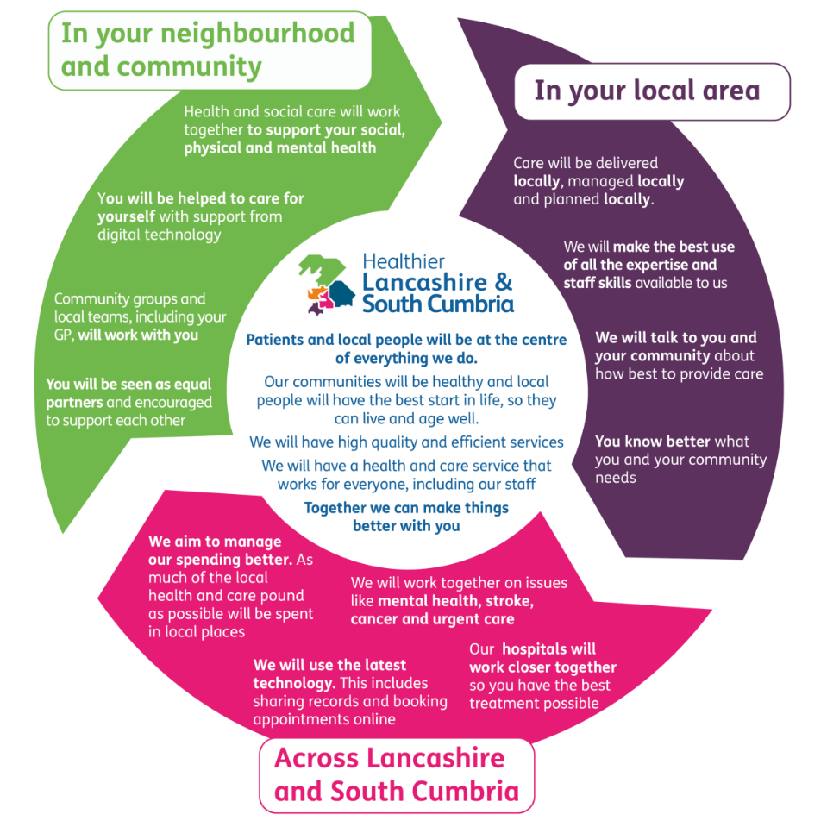
- The narrative needs to answer the more searching questions about what the Integrated Care System partnership is actually for – when there is still evidence of ambivalence about this in the system. The description of the 8 propositions now as partnership priorities is emphasised to make the argument that only in partnership can we respond to some of the most significant challenges we face. On this basis, the priorities are set out as follows in the document:
- Maximise the benefits of our work in neighbourhoods
- Deliver an integrated health and social care workforce for the future with the capacity and capability to provide sustainable care and support to our local communities.
- Strengthen the resilience and mental health of people and communities
- Establish a group model for all hospital services in Lancashire and South Cumbria
- Reinvigorate strategic partnerships across the public sector
- Establish a public sector enterprise and innovation alliance with our Integrated Care System partners, including academic partners and Local Enterprise Partnerships to deliver inward investment and support job creation
- Bring the entire health and social care system back into financial balance
- Consolidate commissioning so that our arrangements for planning and prioritising our resources improve our population’s health and the outcomes of health and social care.

- The accompanying infographic [slide 11 – Appendix 'A'] then illustrates that the intent of the Integrated Care System is to:
  - Support our communities and our staff;
  - Strengthen partnerships/relationships to improve care and promote innovation;
  - Plan to improve our population’s health and our use of resources.

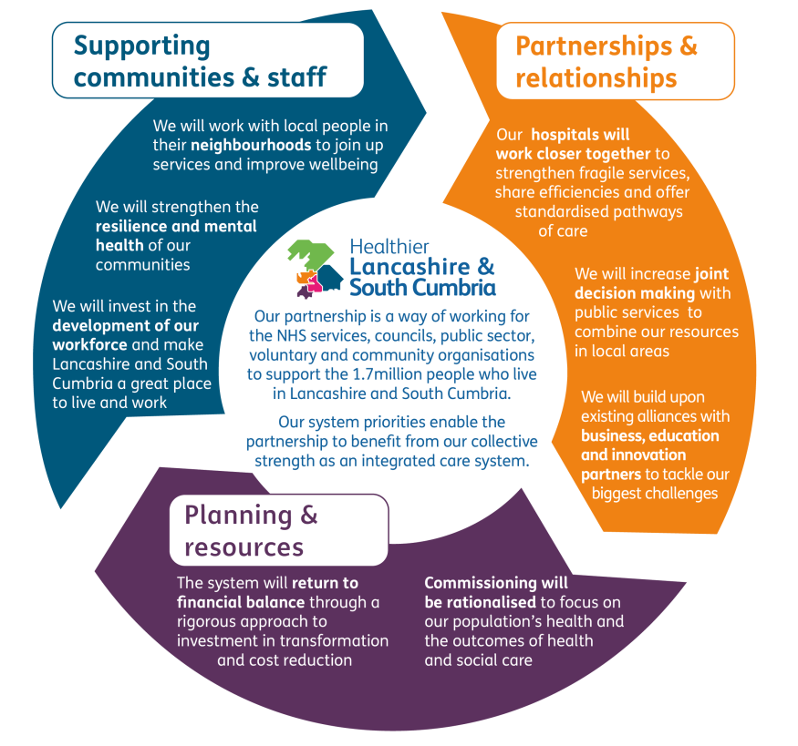

- The narrative needs to be capable of further engagement and co-production with a range of audiences. It is important that we support all partners in involving and embracing this process and learn from the challenges we had in obtaining a consensus when creating Sustainability and Transformation Plans in 2016. Therefore the slide set is intended to act as a core document upon which additional materials will be tailored to public, staff, stakeholder audiences.

- Approval of this approach has now been given by the Integrated Care System Board. It is proposed that system leaders will take the lead for further local engagement, introducing and convening discussions about the purpose of the Integrated Care System strategy with staff in their organisations and members of the public in their Integrated Care Partnerships.. More details are shown in Section 4 of the slide set (Appendix 'A'). Further planning has already started between the Integrated Care System and Integrated Care Partnership communications colleagues to ensure there are realistic expectations of existing communications networks.
Support for system leadership
- There is a recognised need for on-going organisational development across the system as the Integrated Care System partnership develops. Mike Farrar and David Dalton (both former NHS Chief Executives) have already engaged with senior leaders at a workshop earlier this year on this topic and have committed to working with us in supporting the development of the system. They will work specifically with senior leaders over the next few months to enable them to take ownership for the implementation of the strategic plan as well as facilitating discussions to encourage provider collaborations and commissioning reform.

- Positive discussions have already taken place on the 4th April with Chairs and Accountable Officers of Clinical Commissioning Groups about the scope for further reform of the commissioning system. Following this meeting we are seeking a further meeting to agree commitments and rollout of this process. A workshop of Clinical Commissioning Group Chairs and Chief Officers took place at the end of May to develop a roadmap for commissioning which facilitates the continued development of Integrated Care Partnerships and the Integrated Care System.

- In parallel with this approach, David Dalton is arranging further discussions with Provider Chief Executive Officers about the level of ambition for collective approaches.

- Discussions are also taking place with Local Authority Executive leaders about the nature of relationships between the Integrated Care System and Local Government. These are being facilitated independently by Richard Jones, a former Local Government and NHS England director. The outcomes of this process are also directly relevant to the implementation of the Integrated Care System strategy.

Expectations of Clinical Commissioning Groups Governing Bodies and Trust Boards

- The strategic narrative sets out a number of expectations of system leaders upon receipt of the document. Planning meetings will be arranged with Integrated Care Partnership leaders to ensure that the connections between the Integrated Care System partnership priorities and existing Integrated Care Partnership strategies can be clearly articulated.

- In order to support these leaders in delivering these expectations, Clinical Commissioning Groups Governing Body and Trust Board members are asked to:

- Endorse the strategic narrative document as the basis for the development of the Lancashire and South Cumbria (L&SC) Integrated care System (ICS) five year plan
- Endorse in principle the eight priorities within the document, subject to the outcomes of the engagement process
- Endorse the proposed engagement process with patients, citizens, staff and wider partners and support the actions required to deliver it effectively.
- Support the further system development work now being arranged in respect of provider collaboration, commissioning and partnership between local authorities and the NHS.
Recommendations
The [name of Board/Governing Body/group] is asked to:
- Comment on the strategic narrative which has been developed by the Lancashire and South Cumbria Integrated Care System.
- Endorse the strategic narrative document as the basis for the development of the Lancashire and South Cumbria (L&SC) Integrated care System (ICS) five year plan
- Endorse in principle the eight priorities within the document, subject to the outcomes of a proposed engagement process
- Endorse the proposed engagement process with patients, citizens, staff and wider partners and support the actions required to deliver it effectively.
- Support the further system development work now being arranged in respect of provider collaboration, commissioning and partnership between local authorities and the NHS.

Name of CEO/Accountable Officer Dr Amanda Doyle
ICS Chief Officer

